GIS/RS DEPARTMENT DELIVERABLES FOR HYDROMET, MARINE, AGROMET AND WEATHER FORECASTING DEPARTMENT.
- HYDROMET DELIVERABLES
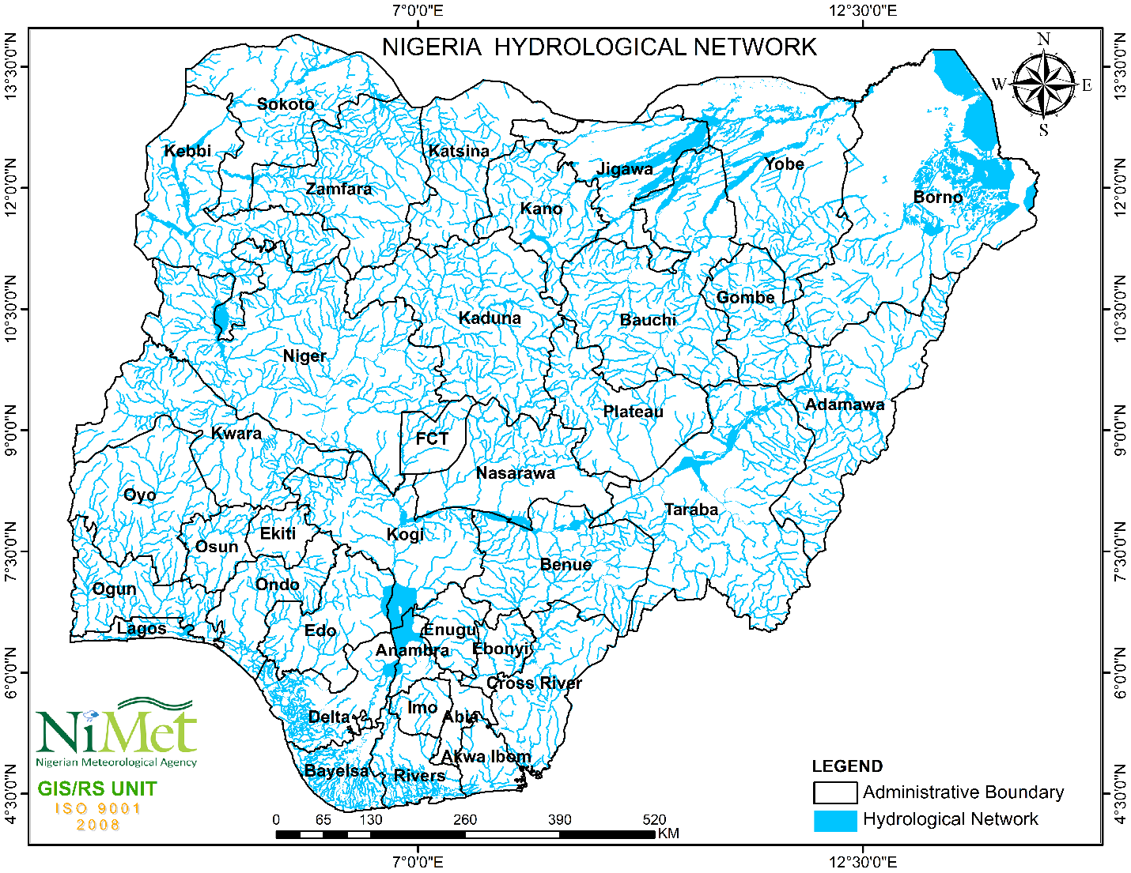
Figure 1: Map of Nigeria Showing the Hydrological Network.
Figure 1 shows the hydrological network of Nigeria which is dominated by two great river systems, namely the Niger-Benue system and the Chad systems. With the exception of a few rivers that empty directly into the Atlantic Ocean (Cross River, Ogun, Osun, Imo, Qua Iboe and a few others), all other flowing waters ultimately find their way into the Chad Basin or down the lower Niger to the sea.

Niger-Benue System
Niger River: The map shows River Niger with its source from the Guinea highlands in Guinea flowing through Sokoto, Kebbi, Niger, Kwara, Kogi, Anambra, Delta and Bayelsa state. It is the third-longest river in Africa behind the Nile and Congo River and it serves as a very crucial component in waterway transportation, agriculture and fishing. Its major tributary is the Benue River which flows through Adamawa, Taraba and Benue state and merges with the Niger River at Lokoja, forming a significant confluence that impacts the hydrology of the region
Chad Basin System:
Lake Chad: Although only a small part of Lake Chad lies within Nigeria, it is a vital water resource for the northeastern part of the country. The Yobe River is a significant tributary that flows into Lake Chad. The rivers flowing into Lake Chad emanate both from the central highland and from the high plateau and converge to form the Yobe River just before flowing into Lake Chad. Some rivers flowing into the lake originate from the Cameroon Mountains. Only a small part of Lake Chad lies within Nigeria.
Other Notable Rivers are; Cross River (which flows directly into the Atlantic Ocean and forms extensive flood plains and wetlands), Ogun, Oshun, Imo and Qua Iboe Rivers. These rivers also empty directly into the Atlantic Ocean and play important roles in their respective regions.

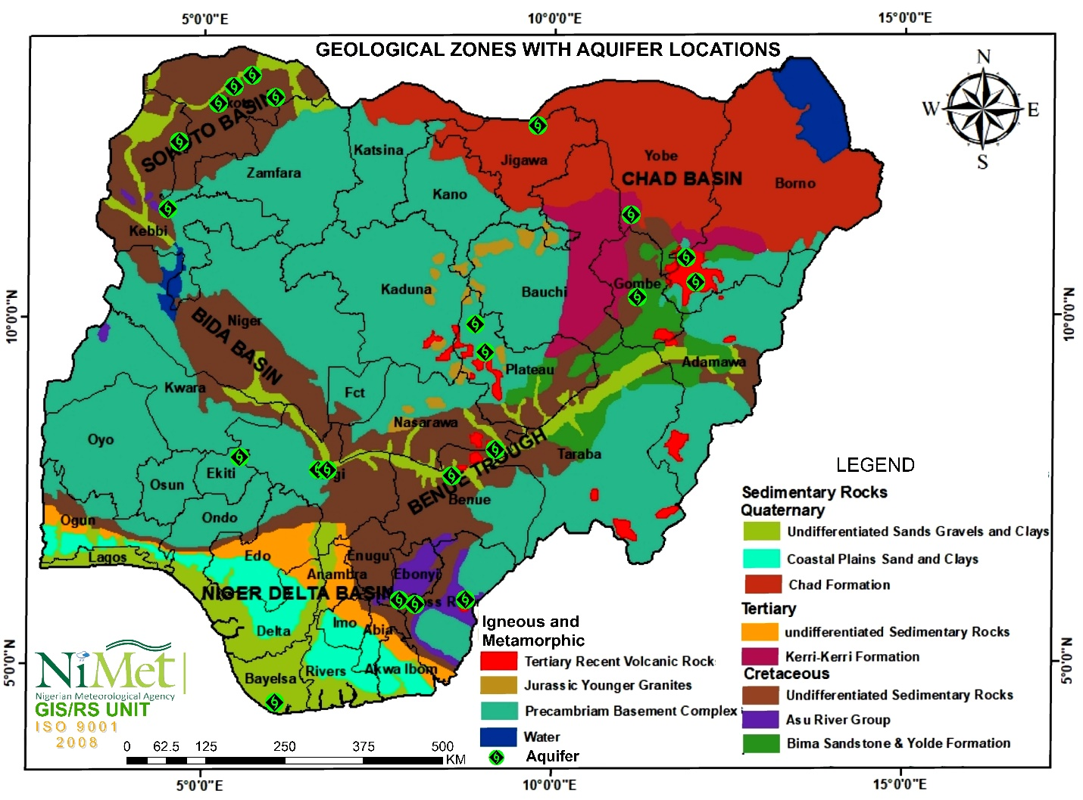
Figure 2: Map of Nigeria Showing the Geological Zones.

Nigeria has a number of aquifers which are dominant and synonymous to each geological zones from the Chad Basin through the Sokoto Basin in the north down to the Niger Delta basin in the south (Figure 2). Aquifers play important roles in the water cycle thereby helping to hold groundwater in the water table and circulate it throughout the earth`s surface and the atmosphere. Additionally, aquifers are vital for the survival of human, plants and animals as they host most of the freshwater available for consumption. Aquifers are also important for agriculture as freshwater is also required to produce the food available for human consumption.
With respect to the geological zones over the country, the following are the types of aquifer we have;
Basement aquifers: Basement rocks can form local aquifers if the degree of weathering and/or fracturing is sufficient. Crystalline and coarse-grain rocks, such as gneiss and migmatite, become sandy on weathering, thus preferentially forming aquifers. Argillaceous meta-sedimentary rocks tend to be become clayey with low permeability when weathered, forming aquitards. Overall, basement aquifers tend not to be high yielding. They typically vary in thickness from 10 to 25 m, with water table depth varying from about 5 to 15 m. Recharge is usually directly from rainfall.
Alluvium: Alluvial aquifers occur along major river valleys, and are thickest (15 - 30 m thick) along the rivers Niger and Benue. Largely unconfined, with shallow water tables. Recharge is directly from rainfall and by infiltration from rivers
Niger Delta Basin: Deltaic Formation, Benin Formation: The unconsolidated aquifers of the Niger Delta Basin are extensive and high yielding. The upper Deltaic Formation is unconsolidated and largely unconfined with shallow water table (0-10 m below ground level) (Offodile 2002). The older Benin Formation is partly consolidated. It is largely unconfined, but locally confined by lower permeability beds. Water table is typically between 3 and 15 m below ground level (Offodile 2002), but can be as much as 55 m deep. The aquifers can provide yields from 3 to 60 l/s. Recharge is mostly directly from rainfall
Volcanic rocks / basalts: Igneous aquifers include volcanic and granitic rocks. The volcanic aquifers generally provide low to moderate yields, usually below 3 l/s. These aquifers are typically unconfined, with typical variations in water table depth of less than 5 m. Aquifer thickness varies substantially. Recharge is directly from rainfall.
Chad, Kerri-Kerri and Gombe formations: The Chad Formation can be unconfined or confined depending on local conditions. Deeper sandstone layers are often confined and can be artesian. Yields of between 2.5 and 30 l/s are quoted. The water table depth is often between 10 and 15 m (Offodile 2002). The Gombe Sandstone has relatively low permeability, usually providing yields of about 1 to 5 l/s. Recharge is usually directly from rainfall.
Sokoto Group (Gwandu and Kalambaina formations); Rima Group (Wurno, Dukamage and Taloka formations); Ilo/Gundimi Formation: The lower sands of the Gwandu Formation are often confined; upper layers are unconfined. Water table can vary from 20 to 100 m depth. Storage is typically high. The Kalambaina Formation is locally permeable with perched aquifers in sandier layers (Offodile 2002). The sand layers of the Wurno Formation are moderately yielding, with a restricted recharge area. The Taloka Formation provides variable yields. It is sometimes confined by clay layers (Offodile 2002). The gritty, conglomeratic and gravel layers of the Ilo/Gundumi Formation act as aquifers, often confined by clayey layers at depth, when artesian conditions can occur.
Nupe Sandstone, Patti & Lokoja Sandstone: The Nupe Sandstone is slightly cemented, but the dominantly fine grained sandstones and interbedded clays, mudstones and siltstones through much of the sequence reduce groundwater potential. The Patti and Lokoja sandstones are thought to have similar hydrogeological characteristics to the Nupe Sandstone. Recharge is directly from rainfall, through any overlying alluvial deposits.
Bima Sandstone, Yolde Sandstone: These formations have relatively low permeability and usually provide poor to moderate yields of about 1 to 5 l/s. They vary substantially in thickness. The water table depth is usually between 60 and 165 m. Recharge is usually directly from rainfall.
Makurdi, Keana, Ezeaku, Awe and Asu River Group formations: These formations tend to be indurated and dominated by fracture flow (although the Makurdi Sandstone is less so). Typical yields are around 2 to 8 l/s, but wide variations are seen, depending on the degree of fracturing and deep weathering. The aquifers therefore tend to be localised, and vary greatly in thickness. They are usually unconfined with the water table at about 10 - 40 m depth. Recharge is usually directly from rainfall.

- MARINEMET DELIVERABLES
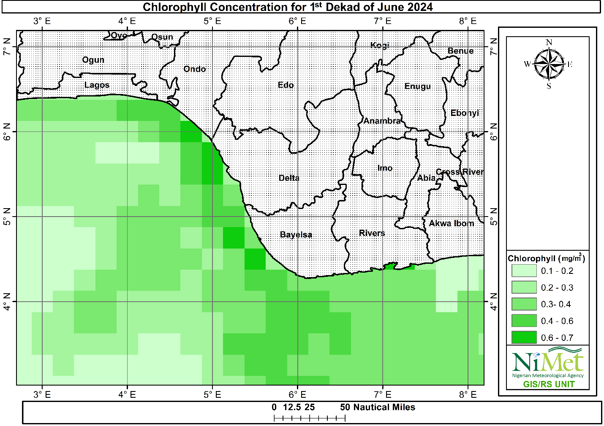
Figure 3: Map Showing Chlorophyll Concentration over the Coast of Nigeria.

Chlorophyll concentration reveals the dynamic interplay of multiple factors, including nutrient availability, sunlight, and the delicate balance of biomass productivity. Higher chlorophyll values indicate nutrient-rich waters where phytoplankton thrive.
The map (Figure 3) shows surface ocean chlorophyll concentration for the first dekad in june 2024, indicating the abundance of phytoplankton majorly within latitude 3ºN and 6.5ºN and longitude 3.9ºE and 6.7ºE particularly over the coast of Bayelsa, Delta, Ondo, Ogun and parts of Lagos coast.
Phytoplankton form the base of the marine food web, converting solar energy into organic matter. This process ultimately feeds the world’s fish, sea birds, marine mammals, and humans. Because phytoplankton use photosynthetic pigments like chlorophyll to convert solar energy into organic matter, the amount of phytoplankton present in the ocean can be assessed by measuring chlorophyll concentrations. When phytoplankton populations are large, the color of the water appears greener because of high concentrations of chlorophyll.
As seen from Figure 3, dark green areas which represent higher chlorophyll concentration ranges between 0.4 mg/m³ and 0.7mg/m³ while light green areas depicting less concentration of chlorophyll ranges between 0.1mg/m³ and 0.3 mg/m³ .Moderate concentration of chlorophyll ranges between 0.3 mg/m³ and 0.4 mg/m³ within the period.
Note that: changes in phytoplankton population may impact fish and other marine life, which can affect economic productivity and food availability. Also, decision makers can use this indicator to understand the health and productivity of marine ecosystem that depend on phytoplankton.

1.3 WEATHER FORECASTING DELIVERABLES
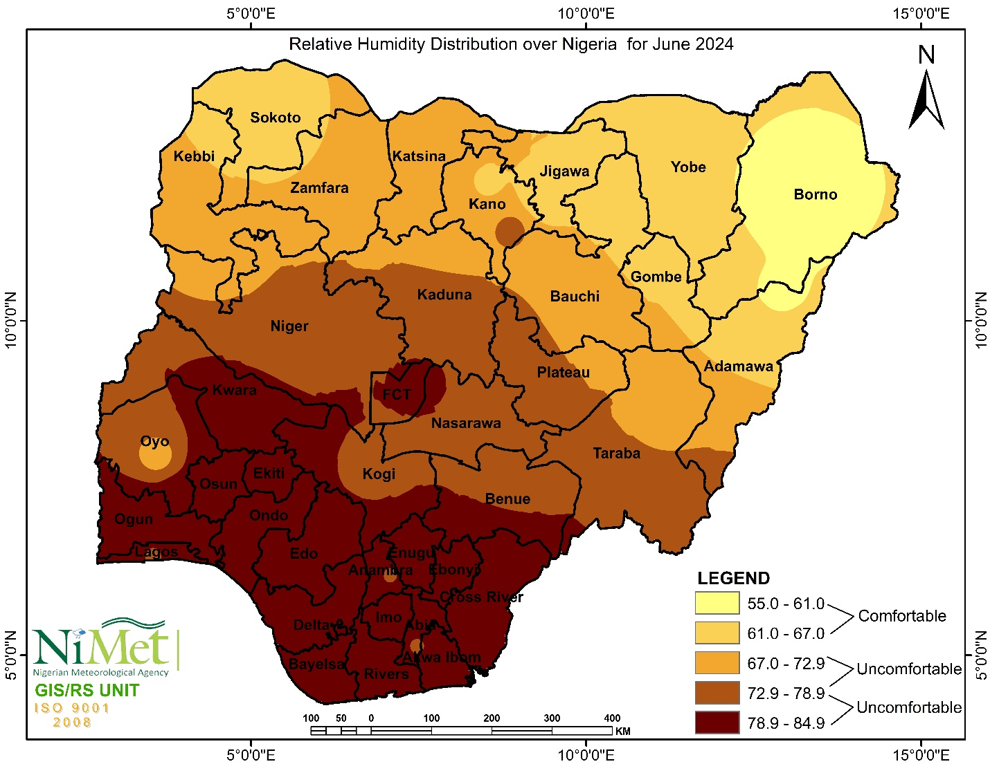
Figure 4: The Relative Humidity Distribution over Nigeria for June 2024 Showing Areas of Comfortable and Uncomfortable Levels Respectively.

The following are the features observed concerning atmospheric moisture distribution over the country in June 2024 as seen from Figure 6:
- The Relative Humidity (RH) over the north-eastern part of the country range between 61% and 67%, except for parts of Borno, Yobe and Adamawa state with record of 55% to 61%.
- The North-western region including parts of Gombe, Bauchi and Adamawa experienced relative humidity ranging between 67% and 79.2%. However, parts of Sokoto, Zamfara and Kebbi state experienced relative humidity range between 55% and 61% during the period.
- Relative humidity range of between 72.9% and 78.9% was observed majorly over parts of Kaduna, Kwara, Kogi, Federal Capital Territory, Nasarawa, Plateau, Benue and Taraba state.
- High Relative Humidity beyond comfortable level in the range of 78.9% and 84.9% was observed mainly over most places in the South- Western, South – Eastern and South-South region apart from parts of Oyo state which experience relative humidity range between 67% and 78.9%.
More moisture influx is expected in the atmosphere with the anticipation of the northward pull of the Inter-Tropical Discontinuity (ITD) line in July 2024.
As part of recommendation, the following tips may be followed to stay cold and dry, even if humidity levels are sky-high:
- Wear the right clothes
- Stay hydrated
- Limit strenuous outdoor activities
- Use anti-perspirant
- Use talcum powder (This is used to keep skin dry and help prevent rashes)
- Use the dehumidifier

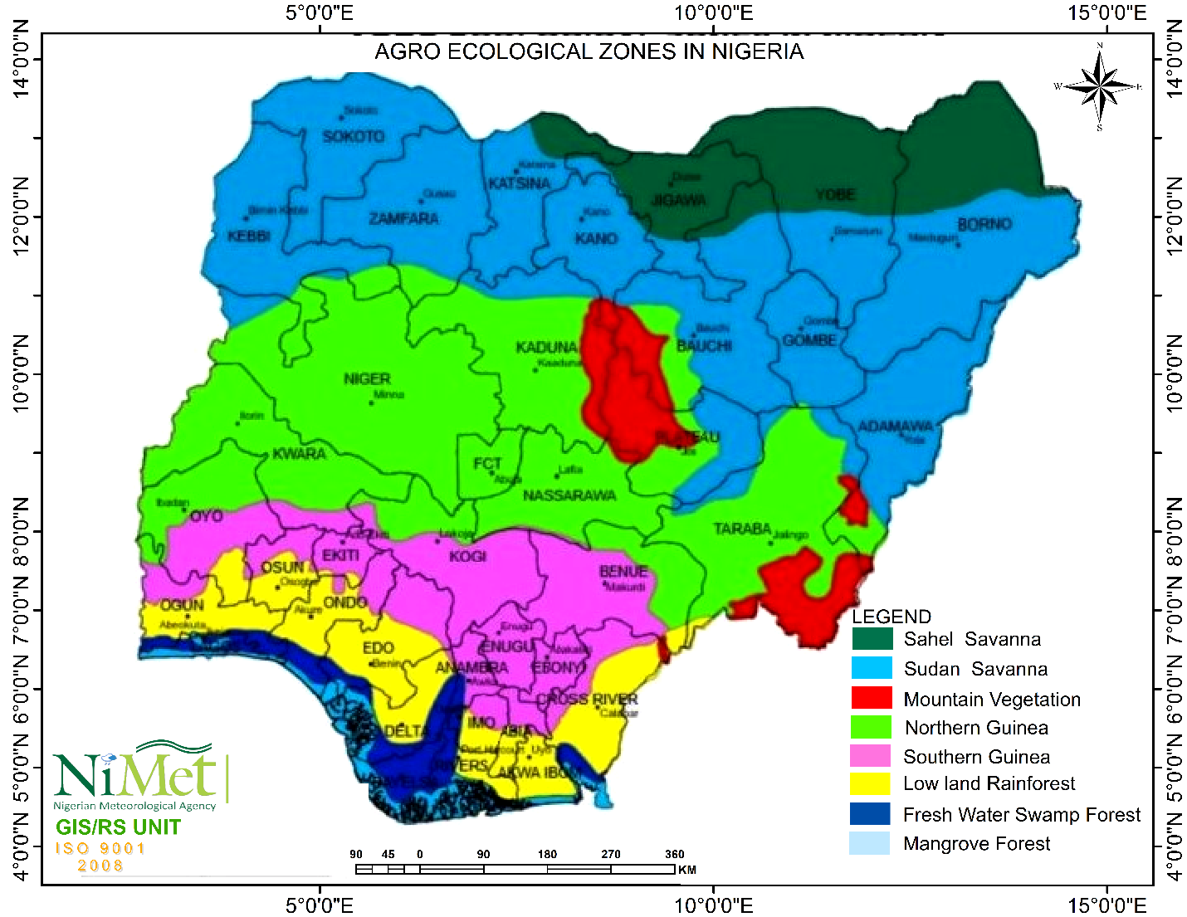
1.4 AGROMET DELIVERABLES
Figure 5: Map Showing the Agro-Ecological zones in Nigeria

Agro-Ecological Zones in Nigeria
Nigeria is known for its large cultural diversity and enormous natural resources ,among which is its agro- ecological diversity defined as the application of ecological ideas and principles in farming . The agro ecological zone helps farming practices in Nigeria, putting farmers and the community in control of agricultural activities. It also gives potentials to local people to adapt agricultural techniques that suit their local areas, specific social, environmental and economic conditions.
Nigeria as a country is geographically separated into numerous agro ecological zones, each with its own class of climatic, soil and topographical characteristics that have a great impact on the country’s agricultural potentials.

Nigeria’s agro ecological zones is categorized into:
- Sahel Savanna
- Sudan Savanna
- Mountain Vegetation
- Northern Guinea Savanna
- Southern Guinea Savana
- Lowland Rainforest
- Fresh water swamp Forest
- Mangrove Forest
The Sahel savanna; this is found in the extreme Northwest and Northeast of the country. It is a transitional eco-region of semi-arid grasslands, savannahs, steppes, and thorn shrubs lying between the wooded savanna to the south, and the Sahara to the north. Examples of these zones are Jigawa and Yobe.

The Sudan savanna; it is found in the Northern parts of Nigeria. It extends from the Sokoto Plain through the Northern section of the High Plains of Nigeria to the Chad Basin. The Sudan savanna is characterized with frequent and high rainfall variability, together with poor soil fertility being a major constraint to agriculture in the region. The zone has the largest population density in Northern Nigeria, producing important economic crops such as groundnuts, cotton, millet, and maize, and it has the highest concentration of cattle in the country. Examples of these zones are Gombe and Zanfara states.

Mountain Vegetation; It is an ecosystem found in mountains. It is influenced by colder weather at moderate elevations. In these places, dense forests are common. Rainfall and a temperate climate cause natural vegetation to vary in Mountain Forest. Example of this zone is Plateau

The Guinea savanna (or savanna woodland/wooded savanna); It can either be the southern or Northern Guinea Savanna. It is the most extensive vegetation in the Middle belt of Nigeria and consists of a mixture of trees and grass. The zone is associated with high humidity .It is also characteristic with woodland savanna, which consists of an open stand of trees, the crowns of which form a canopy from 8 – 20 m or more in height and cover at least 40% of the surface. Tree species include; Shea butter, Oil palm, Isoberlina spp., Danielliaoliveri, Lophiraalata, and Terminalia spp. Examples of these zones are Ogun and Osun (Southern Guinea Savanna) and Nasarawa and Niger(Northern Guinea savanna)

Lowland Rainforest Zone; the rainforest zone covers the southern part of Nigeria, including states like Cross River and Ogun. This zone experience high rainfall throughout the year. They are known to have lush and fertile soil, ideal for a wide range of crops, such as cocoa, oil palm, rubber, and various fruits and vegetables. It is also known for its biodiversity and potential for agroforestry initiatives. Examples of this zone is Akwa Ibom.

The freshwater swamp; the wetland environments which include the freshwater swamp forest form a fringe of coastal vegetation after the mangroves in Nigeria’s Niger Delta region. During the dry season, the terrain is quite uneven, with numerous spots of open water. During the wet season, they are frequently inundated. Examples of these zones are Lagos and Delta states

The Mangrove Forest; this is found along the coastal areas of the Niger Delta region. Nigeria’s Mangrove forest are characterized by brackish water and marshy lands. Fishing and aquaculture are the primary economic activities in this zone due to the closeness to the water bodies. The fertile soil is also suitable for cultivating oil palm and rice. It is important to continuously manage and protect these wetlands to maintain the ecological balance while ensuring the supply of fish and other aquatic resources. Examples of this zone is Bayelsa

